OPTIONAL ACCESSORIES
MODEL | ITEM DESCRIPTION | QTY | UNIT | UNIT PRICE | AMOUNT
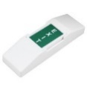 | Small Push Button (to be installed in reception) | 1 | pc | 150.00 | 150.00
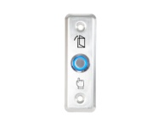 | Slim Push Button | 1 | pc | 800.00 | 800.00
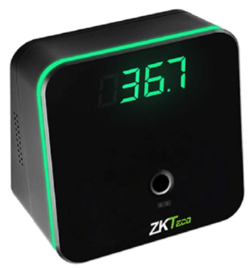  TMD01 | Temperature Detection Module for FA210 | 1 | pc | 9,500.00 | 9,500.00
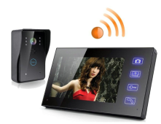 | - 7 inch LCD monitor, the color CMOS camera, with 5 meters cable.  - call function, intercom, lock, monitoring,  - communication without any disturb  - the 3003 core wire outdoor camera, 420 TVL, 92 degree angle.  - Zinc alloy outdoor camera. | 1 | set | 12,500.00 | 12,500.00
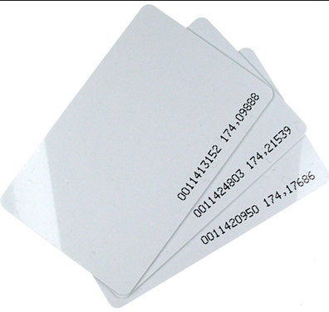 | Proximity Card 125khz(Thin) | 1 | pc | 80.00 | 80.00
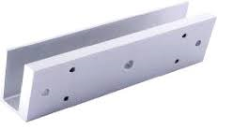 | U-bracket (for frameless Door) | 1 | pc | 1,200.00 | 1,200.00
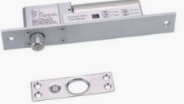 | Dropbolt with L&Z Bracket**  operates with DC 12V  - Function: fail-safe | 1 | Sets | 8,200.00 | 8,200.00
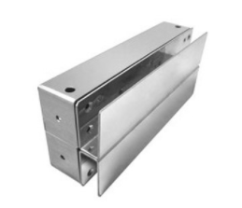 | Aluminum U-Bracket for Dropbolt | 1 | pc | 1,500.00 | 1,500.00
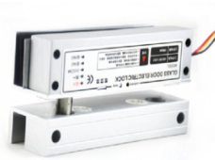 | Drop Bolt Lock for Fully Frame Less Glass Door | 1 | pc | 6,500.00 | 6,500.00
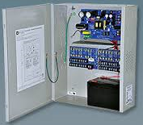  RPS | 12Vdc 5A Regulated Power Supply (with backup battery) | 1 | pc | 4,500.00 | 4,500.00
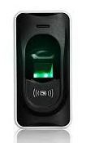  Fr1200 | Biometrics Scanner with Built-in Card Reader  (Slave Device for F22)  12 MONTHS WARRANTY | 1 | pc | 8,500.00 | 8,500.00
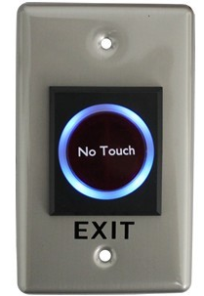  K1 | Touch Free Push to Exit | 1 | pc | 1,200.00 | 1,200.00
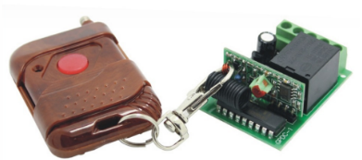  WTTTX KIT2 | ~ Wireless Receiver to Exit with Remote Control  For reception  12V/24VDC | 1 | pc | 1,500.00 | 1,500.00
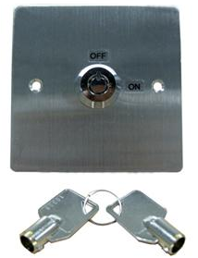 | Emergency Key Switch | 1 | pc | 1,500.00 | 1,500.00
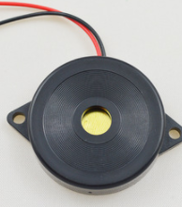 | Door Buzzer | 1 | pc | 350.00 | 350.00
 | Wireless Door Bell | 1 | pc | 1,500.00 | 1,500.00
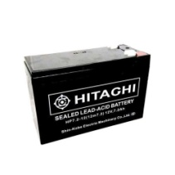  BATTERY | Lead-Acid Battery 12v, 7.2Ah | 1 | pc | 2,500.00 | 2,500.00

